建築系學生修業規定 (STUDENT GUIDELINES)
- 大學部(FOUR-YEAR UNDERGRADUATE PROGRAM)
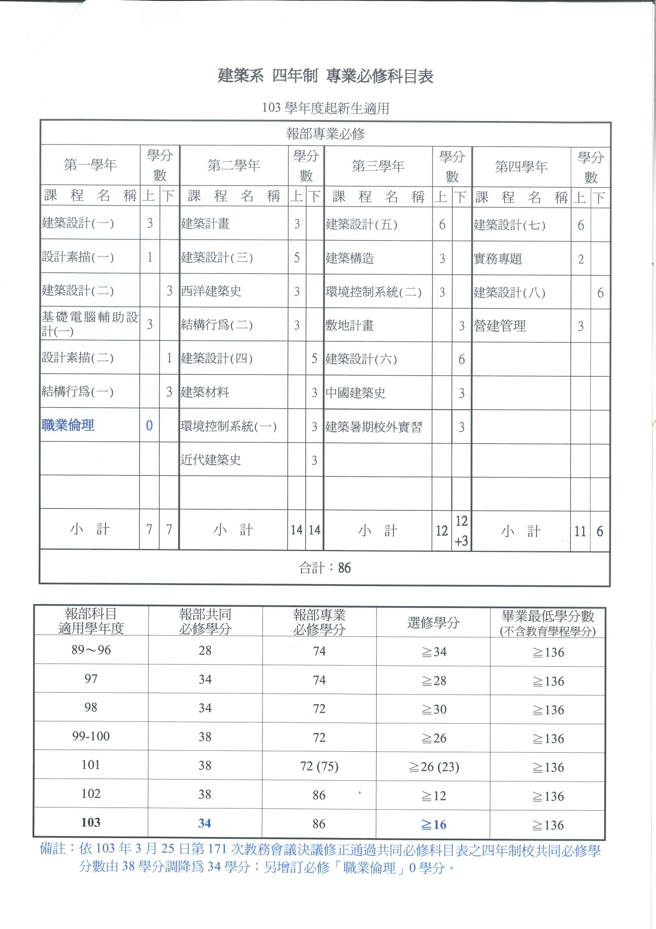
- 研究所課程 (GRADUATE COURSES)
________建築_________研究所專業選修科目開課時程表
中 英 文 科 目 名 稱 | 學  分  數 | 碩士班 |  |  |  | 博士班 |  |  |  | 備 註
 |  | 第一學年 |  | 第二學年 |  | 第一學年 |  | 第二學年
 |  | 上 | 下 | 上 | 下 | 上 | 下 | 上 | 下
建築設計  Architectural Design | 6 | 6 |  | 6 |  | 6 |  | 6
建築設計(一)  Architectural Design (1) | 6 |  | 6 |  | 6 |  | 6 |  | 6
空間暨環境產品創意設計(一)  Space and Environmental product Design | 6 | 6 |  | 6 |  | 6 |  | 6
空間暨環境產品創意設計(二)  Space and Environmental product Design | 6 |  | 6 |  | 6 |  | 6 |  | 6
綠色文化性設施  Green Cultural Facilities | 3 | 3 |  |  |  | 3
數位互動設計  Digital Interaction Design | 3 | 3 |  |  |  | 3
建築師與建築  Architects and Architecture | 3 | 3 |  | 3 |  | 3 |  | 3
3D掃瞄在建築上之應用  Application of 3D Scan in Architecture | 3 | 3 |  |  |  | 3
台灣建築解析  Architecture Analysis in Taiwan | 3 | 3 |  | 3 |  | 3 |  | 3
建築與土地整體開發策略  Integrated Building and Land Development Strategies | 3 | 3 |  | 3 |  | 3 |  | 3
火災安全學  Fire Safety Engineering | 3 | 3 |  | 3 |  | 3 |  | 3
複雜系統行為在建築學上的應用  Complex System Analysis and Simulation in Architectural Study | 3 | 3 |  | 3 |  | 3 |  | 3
建築使用後評估  Post Occupancy Evaluation | 3 | 3 |  |  |  | 3
建築業之競爭策略  Competitive Strategy for Comstruction Industry | 3 | 3 |  |  |  | 3
開放建築  Open Building | 3 | 3 |  |  |  | 3
參數化建模與優化設計方法  Parametric Modeling and Heuristic Design Methods | 3 | 3 |  | 3 |  | 3 |  | 3
建築環境特論  Special Topics on Architecture Environment | 3 | 3 |  |  |  | 3
西方建築造型發展史  History of Western Architectural Form | 3 | 3 |  |  |  | 3
居住環境理論與解析  Theory and analysis on residential environment | 3 | 3 |  |  |  | 3
建築能源解析  Building Energy Analysis | 3 |  | 3 |  |  |  | 3
建築研究解析  Analysis and Research on Architecture | 3 |  | 3 |  |  |  | 3
建築物理環境專論  Special Topics of Building Physical Environment | 3 |  | 3 |  |  |  | 3
建築產業分析  Building Industry Analysis | 3 |  | 3 |  |  |  | 3
構築文化研究  Studies in Tectonic Culture | 3 |  | 3 |  |  |  | 3
都市發展與都市生活  Urban Development and Urban Life | 3 |  | 3 |  |  |  | 3
數位互動設計  Digital Interaction Design | 3 |  | 3 |  |  |  | 3
專案管理  Project Management | 3 |  | 3 |  | 3 |  | 3 |  | 3
建築管理特論  Special Topics on Building Management | 3 |  | 3 |  |  |  | 3
數位造型與快速成型製作  Digital Form and Rapid Prototyping | 3 |  | 3 |  | 3 |  | 3 |  | 3
建築史研究特論  Special Topics on Architectural History | 3 |  | 3 |  |  |  | 3
建築評論  Architectural Criticism | 3 |  | 3 |  |  |  | 3
物業管理專業與實務  Professional Practice of Facility Management | 3 |  | 3 |  |  |  | 3
高等建築計畫學  Advanced Architectural Planning | 3 |  | 3 |  |  |  | 3
建築學研究  Architectural Research | 3 |  | 3 |  |  |  | 3
建築設備工程專論  Special Topics on Building Service Engineering | 3 |  |  | 3 |  |  |  | 3
歷史環境保全  Conservation of Historic Site | 3 |  |  | 3 |  |  |  | 3
都市課題評析  Analysis on Urban Issues | 3 |  |  | 3 |  |  |  | 3
建築品牌與行銷  Architectural Brand and Marketing | 3 |  |  | 3 |  |  |  | 3
設施維護管理  Operation and Maintenance Management | 3 |  |  | 3 |  |  |  | 3
當代建築師評析  Selected Architects of the 20th Century | 3 |  |  | 3 |  |  |  | 3
建築環境調查與定量解析  Investigation and Analysis of Architecture Environment | 3 |  |  | 3 |  |  |  | 3
建築計量方法  Quantitative Methods for Architecture | 3 |  |  | 3 |  |  |  | 3
建築防火避難安全性能設計  Performance-Based Building Fire Safety Design | 3 |  |  |  | 3 |  |  |  | 3
歐陸城市空間美學分析  Esthetic Analysis of Space in European Cities | 3 |  |  |  | 3 |  |  |  | 3
建築採光  Architectural Daylighting | 3 |  |  |  | 3 |  |  |  | 3
建築遊戲設計  Architectural Game Design | 3 |  |  |  | 3 |  |  |  | 3
都市空間與建築設計實踐  Practice of Urban Design and Architecture Project | 3 |  |  |  | 3 |  |  |  | 3
不動產經營與管理  Real Estate Management | 3 |  |  |  | 3 |  |  |  | 3
歷史建築再生  Renewal of Historic Architecture | 3 |  |  |  | 3 |  |  |  | 3
都市空間理論與解析  Theory & Anatomy of Urban Space | 3 |  |  |  | 3 |  |  |  | 3
CAD程式設計  Computer Programming For CAD | 3 |  |  |  | 3 |  |  |  | 3
室內音響學  Room Acoustics | 3 |  |  |  | 3 |  |  |  | 3
建築環境特論  Special Topics on Architecture Environment | 3 |  |  |  | 3 |  |  |  | 3
建築研究特論  Research Topics in Architecture | 3 | 3 |  | 3 |  |  |  |  |  | 在職專班
物業管理專業與實務  Professional Practice of Facility Management | 3 | 3 |  | 3 |  |  |  |  |  | 在職專班
公共建築工程實務  Practical Issues of Public Architecture Engineering | 3 | 3 |  | 3 |  |  |  |  |  | 在職專班
建築與都市科技發展專題  Building and Urban Research and Development | 3 |  | 3 |  | 3 |  |  |  |  | 在職專班
建築系統整合  Building System Integration | 3 |  | 3 |  | 3 |  |  |  |  | 在職專班
建築資訊建模之應用實務  Building Information Modeling-application and Practice | 3 |  |  | 3 |  |  |  |  |  | 在職專班
建築開發企劃  Land Development and Architectural Programming | 3 |  | 3 |  |  |  |  |  |  | 在職專班
台灣建築解析  Architecture Analysis in Taiwan | 3 |  |  |  | 3 |  |  |  |  | 在職專班
合 計 |  | 66 | 66 | 66 | 60 | 57 | 57 | 54 | 51

- 博士班 (PH. D.PROGRAM)
博士班學生修習過程如下圖。

修業規定Program Requirements
需修滿18學分，自99學年度入學者，除外籍生外，依本校154次教務會議決議，均需修習4學分英文課程，如通過相當於全民英檢中級複試之語文測驗或TOEIC 550以上或參加本校「暑期英文密集班」達72小時，並修習學分數達70以上者，得申請免修
The minimum required credit is 18 units. The Ph.D. Starting from 2010 fall semester, all students except international students are required to take 4 credits of English courses. If any student passes General English Proficiency Test Middle level above or TOECI 550 above, he is not required to take English courses.
論文指導Selecting Thesis Advisor
博士生入學後，應於第二次加退課程截止前，選定論文指導教授，由本系專任教師擔任或由本系專任教師與本校外系或本系兼任教師共同指導，並簽訂論文指導同意書繳交系辦
The Ph.D. student has to select a thesis advisor before second drop courses end. The thesis form must be signed by the thesis advisor and submitted to AD office. The academic advisor can be select for AD faculties or co-advised by and AD faculty and a faculty from either the other department in NTUST or adjunct faculty of AD.
指導教授更換Changing Thesis Advisor
研究生於選定指導教授後，若有更換指導教授之必要時，必需商請原指導教授及新指導教授之同意，填寫繳交變更指導教授同意書
但若指導教授欲停止指導特定研究生，請至系上登記，系辦公室將知會該研究生，請該生覓妥新的指導教授後至系辦登記
If a Ph.D. student wants to change his/her thesis advisor, he/she must submit a completed application form to AD office after the request is approved by the current advisor and the new advisor.
If the thesis advisor wants to terminate the instruction to a certain student, the advisor should inform AD office as soon as possible. So that the AD office can advise the student to find a new advisor, and then he/she follows the same application procedure.
畢業論文發表Thesis Publication
每位博士生提出畢業申請時，均需有發表於SCI或是SSCI期刊論文至少一篇，且須為入學後被接受之論文，提出論文第一作者及第二作者均必須是該博士生或本系專任指導教授(或退休教師)，第一作者必須以國立台灣科技大學名義發表，論文必須為博士生論文一部分成果及指導教授共同發表，及必須出國發表至少一篇國際研討會論文
A Ph. D. student has to publish at least one paper from her/his thesis in and international journal which is either indexed in SCI or SSCI. The paper must be published after the student enrolled in the Ph. D. program. The first and the second authors must be the student and her/his thesis advisor (including retired faculty members), in any order. The paper must be different from the one used for the student’s Ph.D. qualifying examination. A Ph. D. student has to present a paper in an international conference before graduation.
畢業論文口試Thesis Defense
論文於SCI或SSCI 期刊發表或接受後(附正本接受函，Email須指導教授簽名)，可申請論口試
學位考試成績不及格而其修業年限尚未滿者，得於次學期或次學年重考，重考以一次為限；重考成績仍不及格者，應令退學。
The Ph.D. student is allowed to defend his/her thesis only after publishing a paper in an international journal. The acceptance letter must be signed by his/her thesis advisor and submitted to the Ad office for documentation.
The Ph.D. student is allowed to defend his/ her thesis once again if failed in the first time. The Ph.D. student failing in the second run of thesis defense will be dropped out form the program.
畢業論文口試時間:依學校上公布之時間內配合提出申請
The date for thesis defense will be announced by the NTIST

- 碩士班 (一般生) (REGULAR MASTER PROGRAM)
修業規定Program Requirements
需修滿24學分，自99學年度入學者，除外籍生外，依本校154次教務會議決議，均需修習4學分英文課程，如通過相當於全民英檢中級複試之語文測驗或TOEIC 550以上或參加本校「暑期英文密集班」達72小時，並修習學分數達70以上者，得申請免修
The minimum required credit is 24 units. The Master’s Starting from 2010 fall semester, all students except international students are required to take 4 credits of English courses. If any student passes General English Proficiency Test Middle level above or TOECI 550 above, he is not required to take English courses.
論文指導教授選定Selecting Thesis Advisor
研究生入學後，應於第二次加退課程截止前，選定論文指導教授，由本系專任教師擔任或由本系專任教師與本校外系或本系兼任教師共同指導，並簽訂論文指導同意書繳交系辦
Master’s student has to select a thesis advisor before second drop courses end. The thesis form must be signed by the thesis advisor and submitted to AD office. The academic advisor can be select for AD faculties or co-advised by and AD faculty and a faculty from either the other department in NTUST or adjunct faculty of AD.
指導教授更換Changing Thesis Advisor
研究生於選定指導教授後，若有更換指導教授之必要時，必需商請原指導教授及新指導教授之同意，填寫繳交變更指導教授同意書
但若指導教授欲停止指導特定研究生，請至系上登記，系辦公室將知會該研究生，請該生覓妥新的指導教授後至系辦登記
If a Master’s student wants to change his/her thesis advisor, he/she must submit a completed application form to AD office after the request is approved by the current advisor and the new advisor.
If the thesis advisor wants to terminate the instruction to a certain student, the advisor should inform AD office as soon as possible. So that the AD office can advise the student to find a new advisor, and then he/she follows the same application procedure.
碩士一般生申請學分抵免Master Program coursed Credit Transfer
碩士一般生申請分抵免，悉依「本校學生抵免學分辦法」辦理。學分之抵免限於本所定訂抵免申請期間 (依本校行事曆為準)，檢具原修課學校正式核發之成績單或成績證明書正本及影印本各乙份，向本系提出申請，但以一次為限。
Refer to the student coursed credit transferring regulation of NTUST. Application must be submitted to the AD office by its due date and with an official transcript and an extra copy. The application is limited to once.
畢業論文口試Thesis Defense
碩士一般生於完成論文初稿，並經指導教授同意後，始得向本系提出論文口試申請
學位考試成績不及格而其修業年限尚未滿者，得於次學期或次學年重考，重考以一次為限；重考成績仍不及格者，應令退學。
Master’s student can apply for oral examination of thesis after her/his draft thesis is approved by advisor.
Master’s student is allowed to defend his/ her thesis once again if failed in the first time. The Master’s student failing in the second run of thesis defense will be dropped out form the program.
畢業論文口試時間:依學校上公布之時間內配合提出申請
The date for thesis defense will be announced by the NTIST
學生研究室鑰匙領用辦法Lab. Key Request
研究生/碩士在職專班學生選定指導教授後，並繳交指導教授同意書後，使得向系上申請研究室鑰匙
After selecting thesis advisor and submitting a completed consent form to the AD office, Master student can apply Lab. Key from AD office.
- EMBA碩士在職專班(EMBA Program)
修業規定Program Requirements
需修滿24學分， The minimum required credit is 24 units.
論文指導教授選定Selecting Thesis Advisor
碩士在職專班學生入學後，應於第二次加退課程截止前，選定論文指導教授，由本系專任教師擔任或由本系專任教師與本校外系或本系兼任教師共同指導，並簽訂論文指導同意書繳交系辦
EMBA student has to select a thesis advisor before second drop courses end. The thesis form must be signed by the thesis advisor and submitted to AD office. The academic advisor can be select for AD faculties or co-advised by and AD faculty and a faculty from either the other department in NTUST or adjunct faculty of AD.
指導教授更換Changing Thesis Advisor
碩士在職專班學生於選定指導教授後，若有更換指導教授之必要時，必需商請原指導教授及新指導教授之同意，填寫繳交變更指導教授同意書
但若指導教授欲停止指導特定研究生，請至系上登記，系辦公室將知會該研究生，請該生覓妥新的指導教授後至系辦登記
If a EMBA student wants to change his/her thesis advisor, he/she must submit a completed application form to AD office after the request is approved by the current advisor and the new advisor.
If the thesis advisor wants to terminate the instruction to a certain student, the advisor should inform AD office as soon as possible. So that the AD office can advise the student to find a new advisor, and then he/she follows the same application procedure.
碩士一般生申請學分抵免Master Program coursed Credit Transfer
碩士在職專班學生申請分抵免，悉依「本校學生抵免學分辦法」辦理。學分之抵免限於本所定訂抵免申請期間 (依本校行事曆為準)，檢具原修課學校正式核發之成績單或成績證明書正本及影印本各乙份，向本系提出申請，但以一次為限。
Refer to the student coursed credit transferring regulation of NTUST. Application must be submitted to the AD office by its due date and with an official transcript and an extra copy. The application is limited to once.
畢業論文口試Thesis Defense
碩士在職專班學生於完成論文初稿，並經指導教授同意後，始得向本系提出論文口試申請學位考試成績不及格而其修業年限尚未滿者，得於次學期或次學年重考，重考以一次為限；重考成績仍不及格者，應令退學。
EMBA student can apply for oral examination of thesis after her/his draft thesis is approved by advisor.
EMBA student is allowed to defend his/ her thesis once again if failed in the first time. The EMBA student failing in the second run of thesis defense will be dropped out form the program.
畢業論文口試時間:依學校上公布之時間內配合提出申請
The date for thesis defense will be announced by the NTIST

